**Operating System**

**(CT-353)**

Lab no 03

**Code:**

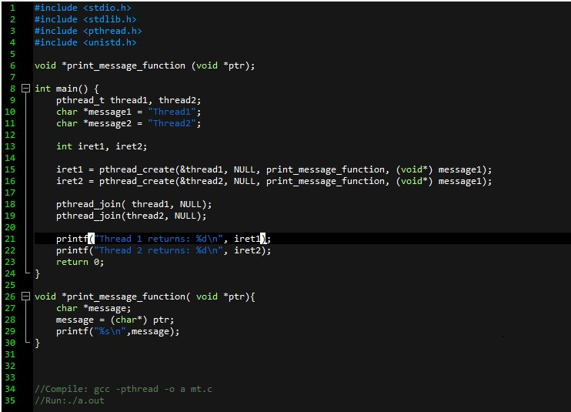

**Output:**

